**Smart Energy Meter for Domestic Usage**

**Submitted By:**

**Sudeep B S- BU21EECE0100524**

**Lakshman B H- BU21EECE0100553**

**Darshan D M- BU21EECE0100564**

**Under the Guidance of**

**Dr. Sundararaman, Assistant Professor**

**(Duration: 01/07/2023 to 24/10/2024)**



**Department of Electrical, Electronics and Communication Engineering**

**GITAM School of Technology**

**GITAM**

**(DEEMED TO BE UNIVERSITY)**

**(Estd. u/s 3 of the UGC Act 1956)**

**NH 207, Nagadenehalli, Doddaballapur taluk, Bengaluru-561203 Karnataka, INDIA.**

# Abstract

In recent years, the emergence of IoT-based smart devices has led to the development of smart homes, societies, communities, and metropolises. A smart megacity is primarily focused on establishing a smart grid that facilitates intelligent management of electricity. For this purpose, it is crucial to have smart meters that can communicate bidirectionally with the network. These meters are not just an accessory but a necessity.

A smart meter is an advanced version of traditional energy meters that offers consumers more information and control over their energy consumption and appliances. These features can range from daily usage readings to central operation of home appliances. However, achieving this level of functionality requires the use of reprogrammable microcontrollers such as Arduino Uno or NodeMCU. These microcontrollers allow manufacturers to upgrade the devices as per the consumer's needs.

Smart meters are considered to be building blocks for Smart Grids, which enable every device to operate in online mode while efficiently managing energy consumption and promoting significant energy conservation.

In this context, this paper proposes an IoT-based smart metering model that provides consumers with their energy consumption units for every 24-hour cycle through SMS and stores this data for generating monthly electricity bills. This approach can help consumers regulate their electricity use and contribute to energy conservation, which is the need of the hour.

**Table of Contents**

Certificate i

Approval ii

Declaration iii

Abstract iv

List of Figures vii

List of Tables viii

Chapter 1 Introduction 1

* 1. History 1
  2. Motivation 2
  3. Technical Details 2

Chapter 2 Literature Review 3

* 1. Introduction 3
  2. Literature Summary 3

Chapter 3 Problem Statement 7

* 1. Problem Definition 7
  2. Aim 7
  3. Objectives 7
  4. Problem Statement 7

Chapter 4 Methodology 8

Chapter 5 Design and Simulation 9

* 1. Hardware Components of the System 9
  2. Circuit Diagram 15
  3. PCB Design 16
  4. 3D-Model of the PCB 17
  5. Code 17
  6. Block Diagram 20
  7. Working 21

Chapter 6 Result and Discussion 23

* 1. Accuracy 23
  2. Discussion 25

Chapter 7 26

Conclusion and Future Scope 26

7.1 Future scope for smart meter 26

References 28

Acknowledgement 30

# List of Figures

Figure 1 - Flowchart of the Project 8

Figure 2 - ZMPT101B(Voltage Sensor) 10

Figure 3 - Arduino UNO(Microcontroller) 11

Figure 4 - GSM Sim800L 13

Figure 5 - Circuit Diagram of Energy meter 15

Figure 6 - PCB Layer 1 16

Figure 7 - PCB Layer 2 16

Figure 8 - 3D model of the PCB design 17

Figure 9 - Block Diagram of the circuit 20

Figure 10 - Working Of the Model 21

Figure 11 – Casing of energy meter 22

Figure 12 – Energy meter in operation 22

Figure 13 - Comparison of the Values displayed and actual values received in DMM 23

Figure 14 - Values in Serial Monitor 24

Figure 15 - Checking the billing cycle on Serial Monitor 24

Figure 16 - Screenshot of the Message Received 25

# List of Tables

Table 1 - Technical specifications of SCT 013 9

Table 2 - Technical Specification of ZMPT101B 10

Table 3 - Technical Specification of Arduino Uno 11

Table 4 - Technical Specification of GSM sim800L 13

Table 5 - Comparison between existing meter and Smart meter 25

**Chapter 1**

**Introduction**

## History

In 1885, the Italian Galileo Ferraris (1847- 1897) made the key discovery that two out-of-phase AC fields could make a solid armature like a disc or cylinder rotate. [1] Independently the Croatian-American Nikola Tesla (1857- 1943) also discovered the rotating electric field in 1888.

[2] Shallenberger also – by accident – discovered the effect of rotating fields in 1888, and developed an AC ampere-hour meter. [3]

These discoveries were the basis of induction motors, and opened the way to induction meters.

[1] In 1889, the Hungarian Otto Titusz Bláthy (1860-1939), working for the Ganz works in Budapest, Hungary, patented his ‘Electric meter for alternating currents’ (Germany No 52,793, USA No 423,210). [1] As the patent describes: ―This meter consists of a metallic rotating body, such as a disk or cylinder, which is acted upon by two magnetic fields displaced in phase from one another. [4]

The said phase displacement of phases results from the fact that a field is produced by the main current, while the other field is excited by a coil of great self-induction shunted from those points of the circuit between which the energy consumed is to be measured. [4] With this arrangement, Bláthy managed to achieve an internal phase shift of exactly 90°, so the meter displayed watt hours correctly.

In the following years, many improvements were achieved: reduction of weight and dimensions, extension of the load range, compensation of changes of power factor, voltage and temperature, elimination of friction by replacing pivot bearings by ball bearings and then by double jewel bearings and magnetic bearings, and improving long-term stability by better brake magnets and eliminating oil from the bearing and the register. [5]

By the turn of the century, three-phase induction meters were developed using two or three measurement systems arranged on one, two or three discs. [6]

Induction meters, also known as Ferraris meters and based on the principles of the Bláthy meter, are still manufactured in copious quantities and are the workhorses of metering, thanks to their low price and excellent reliability. [7]

As the use of electricity spread, the concept of the multi-tariff meter with local or remotely controlled switches, the maximum demand meter, the prepayment meter, and the maxi graph were quickly born, all by the turn of the century. [8]

## Motivation

Due to the problems being faced by the consumers of receiving hefty amounts of bills by the MSEDCL and when we found out the main reason behind this it was because the electricity board officials were not able to visit every single house on the given time of period. The readings which have to be taken manually by reading the kWh readings shown on the display of the meter. This motivated us to bring up a system which runs totally on a remote monitoring reading system which would send the data directly to the electricity company over the internet.

By this project we are hoping to introduce a cheap feasible smart meter which can give the consumer their daily energy consumption, so that they can have control over their daily consumption and also provide transparency between the consumer and Electricity provider.

## Technical Details

It is known as a static energy meter. Supply voltage is given to voltage processing; it consists of a potential transformer, rectifier and amplifier. It steps down the supply voltage to a low value using a potential transformer and is then rectified using a full bridge rectifier. It is then amplified to suit the signals of the micro processors. And then it is given to an analog to digital convertor. And in order to measure the load current it is given to the current processing unit. It consists of a current transformer and a shunt resistor, transformer step downs the value of current and it is given to a shunt resistor. The resistor is used to convert current to voltage equivalent, and then it is given to an analog to digital convertor. Then the data is converted to digital type and it is processed in the microprocessor it calculates the value and the readings are then displayed on the display.

**Chapter 2**

**Literature Review**

## Introduction

In this chapter the relevant techniques in literature are reviewed. It describes various techniques used. Identify the current literature with related domain problems. Identify the techniques that have been developed with their advantages and disadvantages of these methods used.

## Literature Summary

**A Review on Smart Meter System**, Umang Patel, Mitul Modi (December 2015).

This paper explores the possibility of a smart energy grid in India. Smart energy grid would require smart energy meters. It discusses the current energy meters and their working as well as use of digital, accurate meters for better data measurement, storage and transmission. It talks in detail about how Smart grid is not a device but a conglomeration of different measurement, storage and data transfer techniques such as use of GSM, Zigbee, WIMAX and WLAN. It further talks about the working of all these technologies in details and compares them against one another. Finally, it concludes with the infrastructural requirements for a large scale Smart Grid.

We refer this paper for development of smart meter based on GSM.

**Smart Metering for Smart Electricity Consumption** Praveen Vadda, Sreerama Murthy Seelam (May 2013).

This paper has studied the usage patterns of households and has given different techniques to reduce consumption and save electricity. It also talks about measurement through smart meters. It can only be used by us for reading about different types of meters. The mathematical models used in this paper are used to define a relationship between consumption and time. It can used for other things such as water, gas etc.

**Experimental Study and Design of Smart Energy Meter for the Smart Grid** Anmar Arif, Essam A. Al-Ammar, Nayef Al-Mutairi, Yasin Khan (May 2013).

This paper gives details about construction of a smart energy meter that can send consumption data to both consumer and provider using different components such as Wi-Fi Module, GSM, PLC, Zigbee, GPRS etc. It also talks in detail about the software used in the communication system. It also talks briefly about website and mobile app development. It gives constructional details about the meter developed. Constructional details given in this paper can be used to make a smart meter. Also Guidelines for website and mobile app development are useful.

**Smart Energy Meter** Nonofo M. J. Ditshego, Keaboka M Sethebe, Oagile Gaogane, Mompati Molibe, Tshepang Letshwiti, Patrick Mapulane (June 2019).

This paper talks about a smart meter which informs the user about consumption through SMSusing GSM and also a mobile application. This paper addressed the issue of 2G/3G SIMcards being phased out and the solution for it. Detailed constructional details abput the meter are given in this paper along with circuit diagram. This meter also has reote problem sensing technology. The details about integration of GSM with microcontroller are very useful for our project.

### Design and construction of a smart electric metering system for smart grid applications:

Nigeria as a case study Ezeodili Echezona Ugonna, Adebo King Ademola, Akinbulire Tolulope Olusegun (July 2018).

This paper starts with the importance of efficient energy distribution and measurement of power consumption accurately and their role in economy of a nation. Then it moves towards the evolution of energy meters into smart energy meters. It gives construction of a meter but not in detail. It briefly talks about the use of different technologies for data transfer such as

GSM, Radio frequency etc.

The study about metering of energy can help us understand about the details of the energy measurement grid and help in making appropriate features in our project.

**Review on Smart Electric Metering System Based on GSM/IOT** Shaista Hassan Mir , Sahreen Ashruf , Sameena , Yasmeen Bhat and Nadeem Beigh (March 2019).

This paper tells us about a smart meter that develops upon the existing smart meter technologies and incorporates IOT to tranfer data directly over the internet. It also uses GSM

as a backup incase internet is down. It uses internet for two-way communication with consumer as well as provider. It uses the concept of prepaid meter and also talks about displaying remaining balance so that consumer can recharge at appropriate time.

The concepts talked about in this paper can be used in our project for further development of our project model.

**Development of Indigenous Smart Energy Meter adhering Indian Standards for Smart Grid** Sreedevi V S, Prakash Prasannan, Jiju K, Indu Lekshmi J I (May 2020).

This paper talks about smart metering grid across the world and how it can be implemented in India according to Indian standards. It talks about many innovations in the existing meter such as remote data collection, remote payment of bills, sending consumption details to consumers. It also talks about the challenges to Smart Metering in India such as economic considerations on the consumer side before buying a smart meter and gives different techniques to reduce the cost

of meter production to make it affordable. The techniques given in this paper to reduce the cost of manufacturing, such as multi layered

PCB, can prove useful to our project in future.

**Evolution of Smart Metering Systems** Nataša S. Živiü, Obaid Ur-Rehman, Christoph Ruland (November 2015).

This paper has information about problems faced by smart metering devices, such as Eavesdropping, Denial Of Service (DoS) Attacks, Packet Injection Attacks, Malware Injection Attacks, Remote Connect / Disconnect Attacks, Firmware Manipulation Attacks, Man-in-the middle Attacks. List of smart metering projects implemented across EU. It also has different technique for implementation of smart grid and smart metering. Implementation techniques given in this paper can be used by us. Different projects implemented in EU can be studied for reference.

**Cloud-based smart metering system** Peter Dukan, Attila Kovari (November 2013).

This paper talks about the use of cloud computing, to save and retrieve energy consumption related data, instead of conventional server farms. It also tells about different ways to implement this system.

Can be used in programming of Arduino and can be used in storing information about usage and billing of energy.

**Design and Implementation of IoT Based Smart Energy Meter** Saikat Saha, Swagata Mondal, P. Purkait, Anindya Saha (2018).

This paper gives us detailed description about a smart meter that measures and stores data in cloud storge. It displays data through a mobile app. Data is transferred over the internet. It also gives consumption data analysis by showing grahs and patters of energy usage. This will help the user to identify energy saving opportunities and help in energy conservation. This paper gives details about meter construction and mobile app development.

The construction details given in this paper can be useful for our project.

**Error Correction Method for Smart Energy Meter Field Calibration System under Non- standard Conditions** Tan Hengyu, Yao Hejun, Huang Yan, Wang Huanning, Zhao Zhihua and Liu Yuan (2020)

This paper studies the accuracy of smart energy meter field calibration standard device under different current and power factors, develops the error correction method under non-standard conditions. The correction method adopts the method of establishing reference standard value arrays under non-standard conditions to achieve fast and accurate on-site verification and effective measurement performance evaluation of the smart energy meters in use, to explore the measurement work for on-site calibration of smart energy meters under current and power factor in the actual environment.

**GSM-Based Smart Energy Meter with Arduino Uno** Win Adiyansyah Indra, Fatimah Bt Morad, Norfadzlia Binti Mohd Yusof, Siti Asma Che Aziz (March 2018)

This paper interfaces a Arduino Uno with a energy meter. This does not give any details about measurement of energy, it directly moves to interfacing of Arduino with energy meter.

Next it interfaces GSM with Arduino Uno. GSM is used to send monthly SMS to user to show their bill and energy consumption.

The code given in this paper is useful to us in this project. Interfacing of Arduino and GSM is also useful to us.

**IOT Based Smart Energy Meter for Efficient Energy Utilization in Smart Grid.** Bibek Kanti Barman, et al.

This paper explains how Arduino IDE software is used to calculate the pulse of an energy meter via optocoupler. It also has excellent power theft detection.

The IoT concept can also be implemented in various working environments such as home automation, automatic water level detector and traffic control system etc.

**IoT Based Smart Energy Metering System for Power Consumers.** Md. Mohitul Haque et al. This shows us that the IoT based energy metering system has been devised with ADE7758 energy measurement IC. GUI (Graphical user interface) is used here to monitor the system. Constructional details given in this paper can be used to make a smart meter. It can help to

manufacture a low-cost meter

**A new IoT-based smart energy meter for smart grids** Danielly B. Avancini et al.

The authors in this paper use an SG method to monitor, control, and protect energy generation, transmission, and distribution systems in an economical way.

Implementation of smart meters is done by IOT Middleware. It can also be used to send wireless information using IOT middleware and other components.

**A Smart Meter Design Implemented with IOT Technology** Chang-Pei Yi et al.

The authors in the paper focuses on the architecture design of the monitoring and servo terminals, to perform power calculations instantly when the signal is received.

In future this can be used for spontaneous calculation of the received signal for better understanding on the power consumption.

**Design and Implementation of IoT Based Smart Energy Meter.** Saikat Saha et al.

This paper talks about how Arduino UNO is more feasible to use than raspberry pi and how to reduce overall costing of the meter. It uses an Arduino UNO with an embedded Wi-Fi module for easy connection.

Use of the IOT based concept makes it more versatile for the future of domestic power rating meters.

**Chapter 3**

**Problem Statement**

## Problem Definition

The problem statement of this project is to develop a smart monitoring system that can be integrated into traditional energy meters. The purpose of this system is to provide consumers with a billing statement that reflects their energy consumption within a 24-hour period.

## Aim

Aim of this project is to make a smart meter which can measure, display and send the electricity readings of the customers consumption on a 24hrs cycle via SMS.

## Objectives

1. To understand how an electric meter collects consumption measurement (reading).
2. To make a smart meter using Arduino UNO as a micro-processor.
3. To understand how readings can be send via SMS.
4. To develop a model which sends everyday usage to consumers via SMS.
5. To implement an anti-theft system to protect the Arduino code from tempering.
6. To ensure correct readings are send in accordance with the time cycle.

## Problem Statement

The goal of this project is to enhance transparency in the billing process and promote responsible and efficient energy use among consumers. This will be achieved by providing consumers with a daily energy consumption report along with the corresponding bill amount. The availability of such information will encourage consumers to be more mindful of their energy use and to adopt more responsible and efficient energy consumption habits.

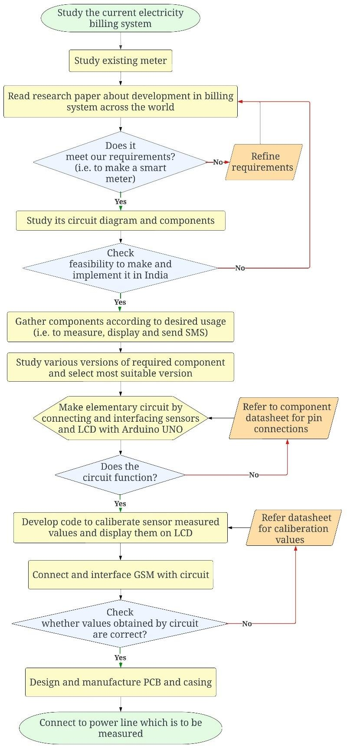**Chapter 4** **Methodology**

### Figure 1 - Flowchart of the Project

**Chapter 5** **Design and Simulation**

## 5.1 Hardware Components of the System

### Current Sensor (SCT-013)

SCT-013-000 is a Non-Invasive AC current sensor i.e. it is a current transformer that can be used to measure AC current up to 100 amperes. [9] This non-invasive current sensor clamped around the supply line can measure a load up to 30 Amps, and allow you to calculate how much current pass through it. [10] It can be useful for building your own energy monitor or for building an overcurrent protection device for an AC load. [10]

Technical Specifications:

### Table 1 *-* Technical specifications of SCT 013

|  |  |
| --- | --- |
| **Operation** | **Range** |
| Operation temperature | -25℃～+70℃ |
| Storage temperature | -30℃～+90℃ |
| Work voltage | ≤660V |
| Work frequency | 50Hz-1KHz |
| Dielectric strength | 3.5KV 50Hz 1min |

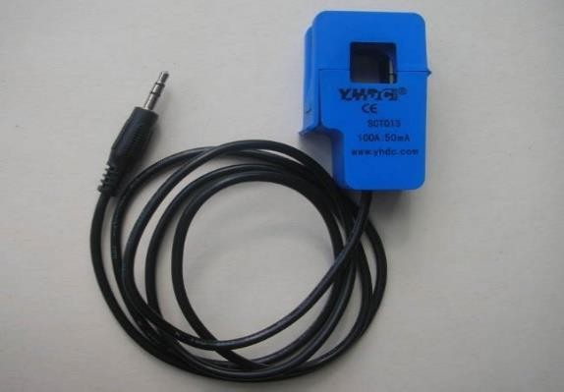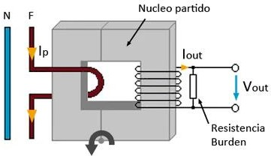

### Figure 2(a)- SCT013-000(Current Sensor) Figure 2(b)- Working

They operate by magnetically inducing current from the conductor they are placed on into a proportional electric current that flows through the CT conductors. They make it possible for

power meters to measure current on circuits that, if they measured the current directly, would overpower the meters. If you want to monitor power, you need to use CTs. [11]

### Voltage Sensor (ZMPT101B)

The ZMPT101B is an AC voltage sensor module that can measure AC voltages. Its output is analog and varies as the input voltage changes. The module uses a resistive voltage divider circuit-based DC voltage sensing device to generate an analog output. [12] ZMPT101B AC Voltage Sensor is the best for the purpose of the DIY project, where we need to measure the accurate AC voltage with a voltage transformer. [13] This is an ideal choice to measure the AC voltage using Arduino/ESP8266/Raspberry Pi like an open source platform. [13]

Technical Specifications:

### Table 2 - Technical Specification of ZMPT101B

|  |  |
| --- | --- |
| **Operation** | **Range** |
| Primary Current | 2 mA |
| Secondary Current | 2 mA |
| Current Range | 0-3 mA |
| Frequency Range | 50-60 Hz |
| Dielectric Level | 3000 VAC/min |

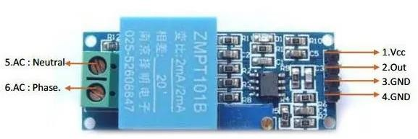

### Figure 2 - ZMPT101B(Voltage Sensor)

### Arduino UNO

The Arduino UNO is the best board to get started with electronics and coding. [14] If this is your first experience tinkering with the platform, the UNO is the most robust board you can start playing with. [14] The UNO is the most used and documented board of the whole Arduino family. [14] Arduino UNO is a microcontroller board based on the ATmega328P. [15] It has 14 digital input/output pins (of which 6 can be used as PWM outputs), 6 analog inputs, a 16 MHz ceramic resonator, a USB connection, a power jack, an ICSP header and a reset button. [16] It contains everything needed to support the microcontroller; simply connect it to a computer with a USB cable or power it with a AC-to-DC adapter or battery to get started. [17] You can tinker with your UNO without worrying too much about doing something wrong, worst case scenario you can replace the chip for a few dollars and start over again. [14]

### Technical Specification:

### Table 3 - Technical Specification of Arduino Uno

|  |  |
| --- | --- |
| Microcontroller | ATmega328P |
| Operating volt | 5V |
| Input volt. | 7-12V |
| Input volt. (limit) | 6-20V |
| Digital I/O Pins | 14 (6PWM output) |
| Digital I/O Pins | 6 |
| Analog Input Pins | 6 |
| Flash memory | 32KB |
| Clock Speed | 16 MHz |
| LED_BUILTIN | 13 |
| Length | 68.6mm |
| Width | 53.4mm |

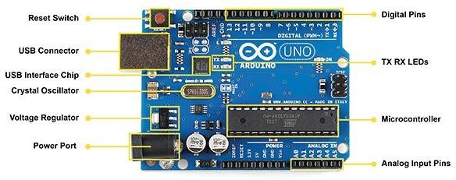

### Figure 3 - Arduino UNO(Microcontroller)

### Pin Description of Arduino UNO(R3):

**Vin:** This is the input voltage pin of the Arduino board used to provide input supply from an external power source.

**5V:** This pin of the Arduino board is used as a regulated power supply voltage and it is used to give supply to the board as well as onboard components.

* 1. **V:** This pin of the board is used to provide a supply of 3.3V which is generated from a voltage regulator on the board

**GND:** This pin of the board is used to ground the Arduino board.

**Reset:** This pin of the board is used to reset the microcontroller. It is used to Resets the microcontroller.

**Analog Pins:** The pins A0 to A5 are used as an analog input and it is in the range of 0-5V.

**Digital Pins:** The pins 0 to 13 are used as a digital input or output for the Arduino board.

**Serial Pins:** These pins are also known as a UART pin. It is used for communication between the Arduino board and a computer or other devices. The transmitter pin number 1 and receiver pin number 0 is used to transmit and receive the data resp.

**External Interrupt Pins:** This pin of the Arduino board is used to produce the External interrupt and it is done by pin numbers 2 and 3.

**PWM Pins:** This pins of the board is used to convert the digital signal into an analog by varying the width of the Pulse. The pin numbers 3,5,6,9,10 and 11 are used as a PWM pin.

**SPI Pins:** This is the Serial Peripheral Interface pin, it is used to maintain SPI communication with the help of the SPI library. SPI pins include:

* + 1. SS: Pin number 10 is used as a Slave Select
    2. MOSI: Pin number 11 is used as a Master Out Slave In
    3. MISO: Pin number 12 is used as a Master In Slave Out
    4. SCK: Pin number 13 is used as a Serial Clock

**LED Pin:** The board has an inbuilt LED using digital pin-13. The LED glows only when the digital pin becomes high.

**AREF Pin:** This is an analog reference pin of the Arduino board. It is used to provide a reference voltage from an external power supply.

### 4. GSM (SIM 800L)

The SIM800L is a GSM module from Simcom that gives any microcontroller GSM functionality, meaning it can connect to the mobile network to receive calls and send and receive text messages, and also connect to the internet using GPRS, TCP, or IP. [18] Another advantage is that the board makes use of existing mobile frequencies, which means it can be used anywhere in the world. [18]

### Technical Specifications :

### Table 4 - Technical Specification of GSM sim800L

|  |  |
| --- | --- |
| **Operation** | **Range** |
| Power Supply | 3.4 - 4.4V |
| Power saving | Typical power consumption in sleep mode is  0.7mA (AT+CFUN-0) |
| Frequency bands | Quad-band: GSM 850, EGSM 900, DCS  1800, PCS 1900. SIM8001. can search the 4 frequency bands automatically. The frequency bands can also be set by AT command "AT+CBAND".  Compliant to GSM Phase 2/2+ |
| Transmitting power | Class 4 (2W) at GSM 850 and EGSM 900  Class 1 (IW) at DCS 1800 and PCS 1900 |
| GPRS connectivity | GPRS multi-slot class 12 (default)  GPRS multi-slot class 1-12 (option) |
| Normal operation | -40°C - +85°C |

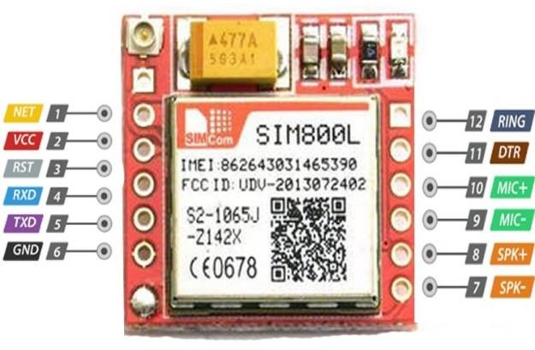

### Figure 4 - GSM Sim800L

### Pin Description of GSM SIM800L:

NET: is a pin where you can solder the helical antenna that comes with the module.

VCC: is the Power supply pin of the module and it needs to be powered anywhere from 3.4V to

4.4 volts. Connecting this module to a 5V supply will most likely destroy it and if you connect it to 3.3V it won't even run. A lithium battery or a buck converter with 2A current capacity is recommended for this module.

RST: is the hard reset pin of the sim800L module. If you are having trouble communicating with this, pull the pin low for 100ms.

RXD: is the RX pin for the module used in serial communication. TXD: is the TX pin for this module used in Serial communication.

GND: is the Ground pin for this module; connect this pin to the Ground pin of the ESP32.

RING: is the ring indicator pin of the module. This pin generally is active high. It will go low for 120ms to indicate incoming calls and can also be configured to pulse when an SMS is received.

DTR: this pin can be used to put the module in sleep mode. Pulling the pin high puts the module in sleep mode and disables the serial***.*** Pulling it low will wake the module up.

MIC+-: These two pins can be used to connect an external microphone to the module. SPK+-: These two pins can be used to connect an external speaker to the module.

## A picture containing text, diagram, plan, line Description automatically generatedCircuit Diagram

### Figure 5 - Circuit Diagram of Energy meter

## PCB Design

A printed circuit board, or PC board, or PCB, is a non-conductive material with conductive lines printed or etched. Electronic components are mounted on the board and the traces connect the components together to form a working circuit or assembly. [19]

A PC board can have conductors on one side or two sides and can be multi-layer — a sandwich with many layers of conductors, each separated by insulating layers. [19]

The most common circuit boards are made of plastic or glass-fiber and resin composites and use copper traces, but a wide variety of other materials may be used. Most PCBs are flat and rigid but flexible substrates can allow boards to fit in convoluted spaces. Components are mounted via SMD (surface-mount) or through-hole methods. [19]

We went for 2 layer PCB because of overlapping wires on a single layer of circuit.

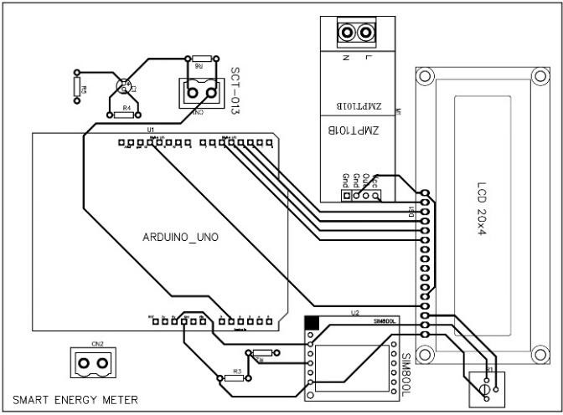

### Figure 6 - PCB Layer 1

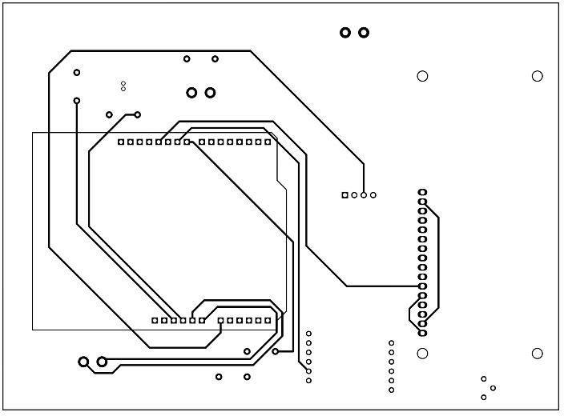

***Figure 7* - PCB Layer 2**

## 3D-Model of the PCB

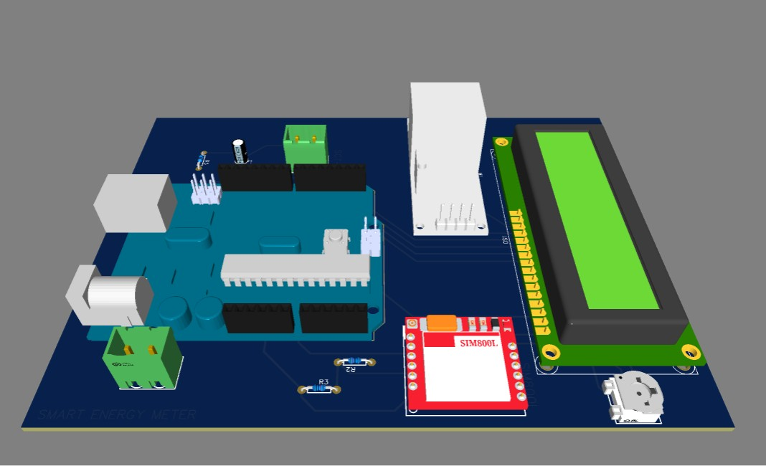

### Figure 8 - 3D model of the PCB design

## Code

Code for Arduino provided below is written by us:

#include <Arduino.h> #include<math.h> #include <Wire.h> #include <string.h>

#include <LiquidCrystal.h> #include <SoftwareSerial.h>

#include "EmonLib.h" //https://github.com/openenergymonitor/EmonLib

SoftwareSerial sim800l(9, 8); // RX, TX pins of SIM800L connected to Arduino pins 8 and 9 respectively

LiquidCrystal lcd(12, 11, 5, 4, 3, 2); // Initialize the library with the pins used EnergyMonitor emon;

#define vCalibration 234.26

#define currCalibration 52 float bill=0;

float kWh = 0;

unsigned long lastmillis = millis(); unsigned long lastsend = millis();

void serial_print() { emon.calcVI(20, 2000); Serial.print("Vrms: "); Serial.print(emon.Vrms, 2); Serial.print("V");

Serial.print("\tIrms: "); Serial.print(emon.Irms, 4); Serial.print("A");

Serial.print("\tPower: "); Serial.print(emon.apparentPower, 4); Serial.print("W");

Serial.print("\tkWh: ");

kWh = kWh + emon.apparentPower*(millis()-lastmillis)/3600000000.0; Serial.print(kWh, 4);

Serial.println("kWh"); lastmillis = millis();

Billing();

Serial.print("\t Bill:-Rs."); Serial.print(bill,4); Serial.print("/-");

String data = "kWh: " + String(kWh, 4) + ", Bill: Rs. " + String(bill, 4) + "/-"; // create a string with kWh and bill data

Serial.println(data);

sim800l.println("AT+CMGS=\"+918169942976\"\r"); // send SMS to phone number

}

void lcd_print() {

lcd.setCursor ( 0, 1 ); //LCD Cursor set lcd.print("V: "); //print voltage lcd.print(emon.Vrms, 2);

lcd.print("V");

lcd.setCursor ( 11, 1 ); //LCD Cursor set lcd.print("I: "); //print Current lcd.print(emon.Irms, 2);

lcd.print("A");

lcd.setCursor ( 0, 2 ); //LCD Cursor set lcd.print("P: "); //print Power lcd.print(emon.apparentPower, 4); lcd.print("W");

lcd.setCursor ( 0, 3 ); //LCD Cursor set lcd.print("E: ");

lcd.print(kWh, 4); lcd.print("kWh");

}

void Billing(){ bill=0;

if(kWh>0 && kWh<=100)

{

bill += 105 + 3.36*kWh;

}

else if(kWh>=101 && kWh<=300)

{

bill += 105 + 7.34*kWh;

}

else if(kWh>=301 && kWh<=500)

{

bill += 105 + 10.37*kWh;

}

else if(kWh>=501 && kWh<=1000)

{

bill += 105 + 11.86*kWh;

}

else if(kWh>1000)

{

bill += 105 + 11.86*kWh;

}

}

void setup() { Serial.begin(9600);

sim800l.begin(9600);

lcd.begin(20, 4); // Set up the LCD's number of columns and rows

emon.voltage(0, vCalibration, 1.7); // Voltage: input pin, calibration, phase_shift emon.current(1, currCalibration); // Current: input pin, calibration.

lcd.setCursor ( 1, 0 ); //LCD Cursor set

lcd.print("SMART ENERGY METER"); //LCD print Smart energy meter as heading

}

void loop() {

serial_print(); // to run in serial monitor continuously

lcd_print(); // to continuously change reading in lcd according to real time

// Send data every hour

if (millis() - lastsend >= 86400000) { // if 24 hour has passed

String data = "kWh: " + String(kWh, 4) + ", Bill: Rs. " + String(bill, 4) + "/-"; // create a string with kWh and bill data

sim800l.println("AT+CMGS=\"+918169942976\"\r"); // send SMS to phone number lastsend = millis(); // store the current time

}

delay(500);

}

## Block Diagram

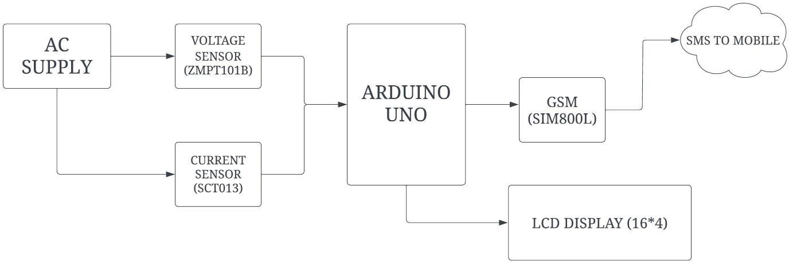

### Figure 9 - Block Diagram of the circuit

## Working

1. Voltage sensor is connected across the supply line which measures the voltage and sends it to the Arduino.
2. Current sensor measures current in either of the live or neutral wires and sends it to the Arduino.
3. The Arduino accepts the values of both the sensors via analog pins.
4. The code uploaded in the Arduino is designed to calibrate voltage and current readings
5. Power and Energy are calculated from voltage and current values.
6. These values are now sent to the LCD to be displayed and to GSM to be sent via SMS.

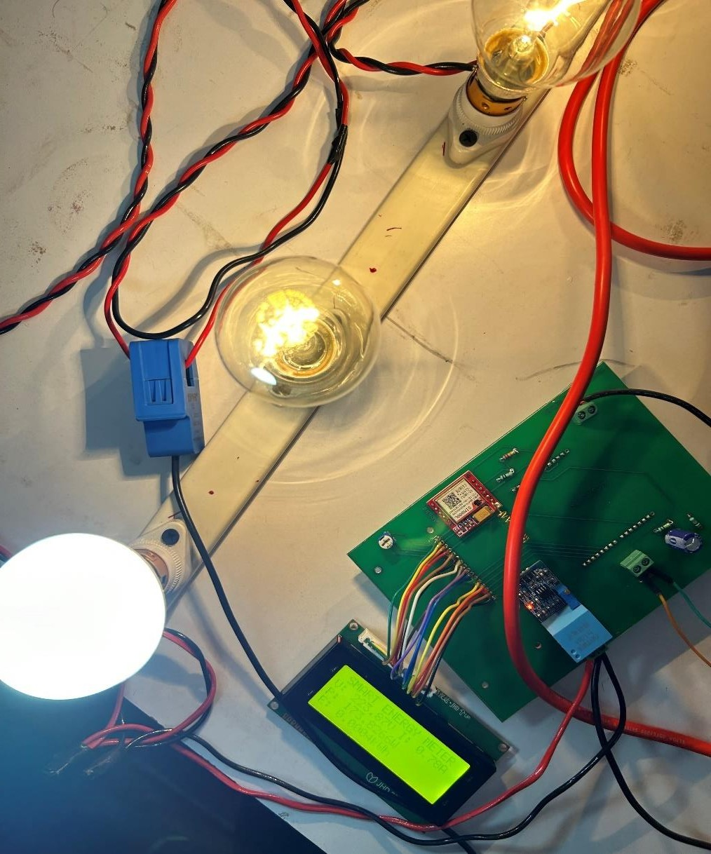

### Figure 10 - Working Of the Model

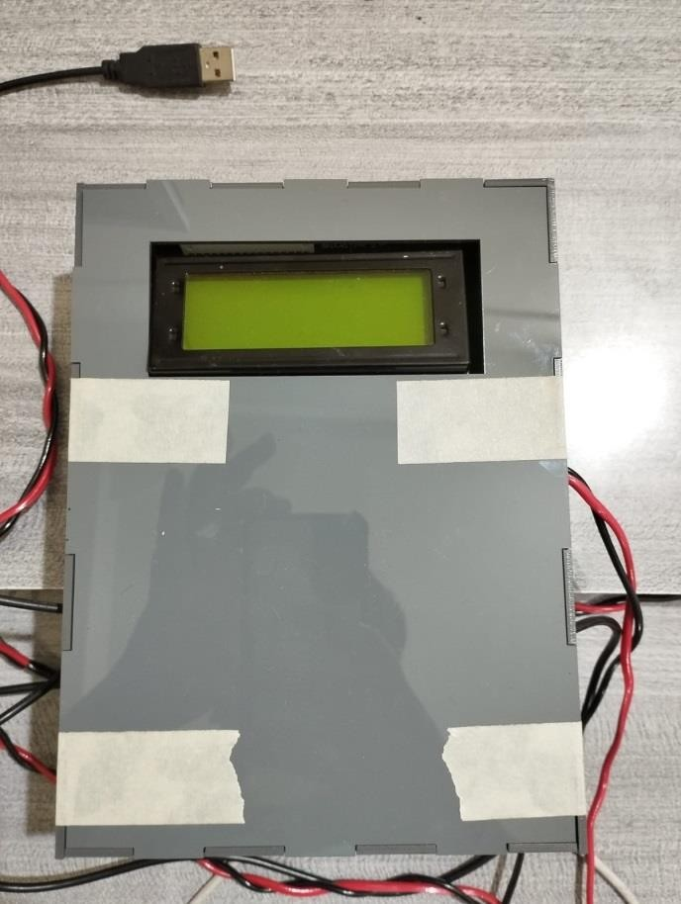

### Figure 11 – Casing of energy meter

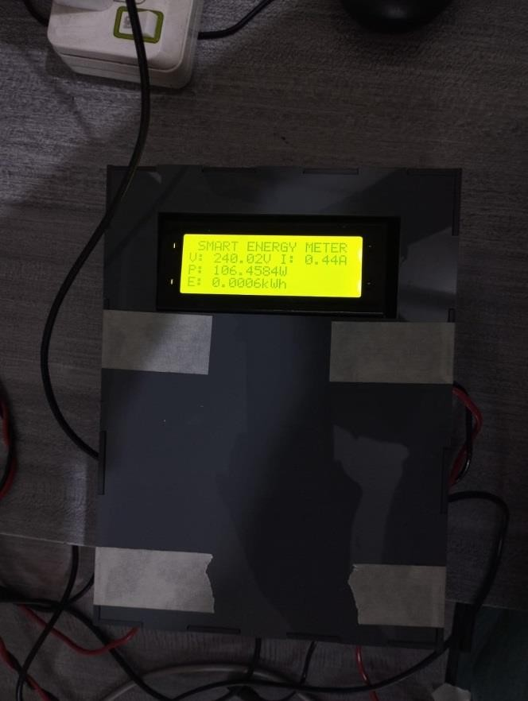

### Figure 12 – Energy meter in operation

**Chapter 6** **Result and Discussion**

## Accuracy

Accuracy of the readings is an important aspect of a energy meter. Without accuracy the results obtained would be useless. We used a multimeter to physically check the current the circuit and cross checked it with the readings obtained on the LCD screen. Multimeter was connected exactly where the SCT013 is connected to avoid any mismatch in values.

The values obtained on LCD screen were almost equal to the values obtained in the multimeter. The results are given below:

Error: -

Observed Value – 0.49A True Value – 0.48A Error (%) – 2.0833%

Justification: - Calibration error in multimeter or sensor inaccuracy

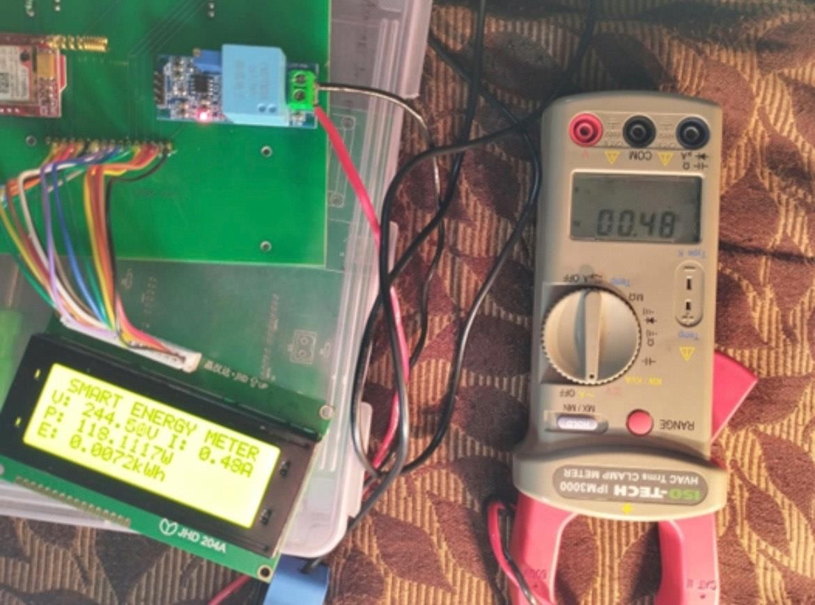

### Figure 13 - Comparison of the Values displayed and actual values received in DMM

**OUTPUT(Serial Monitor)**

Output of the meter reading can be seen on serial monitor as well as on mobile screen.

The readings can be obtained on the serial monitor of Arduino IDE if we do not have LCD with us. This is where we checked the accuracy of our preliminary circuit and code. The readings displayed on serial monitor can be seen below.

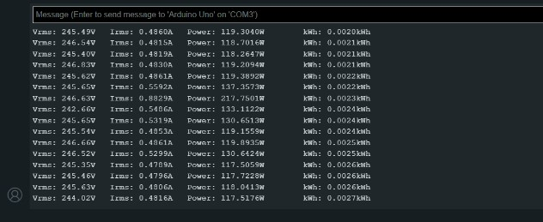

### Figure 14 - Values in Serial Monitor

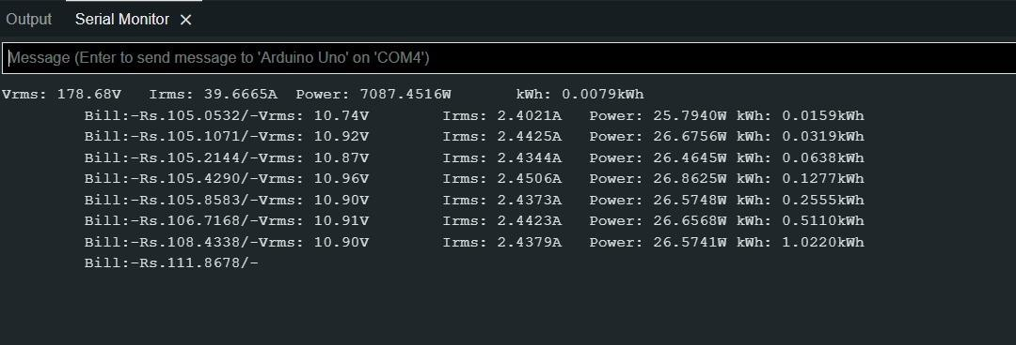

### Figure 15 - Checking the billing cycle on Serial Monitor

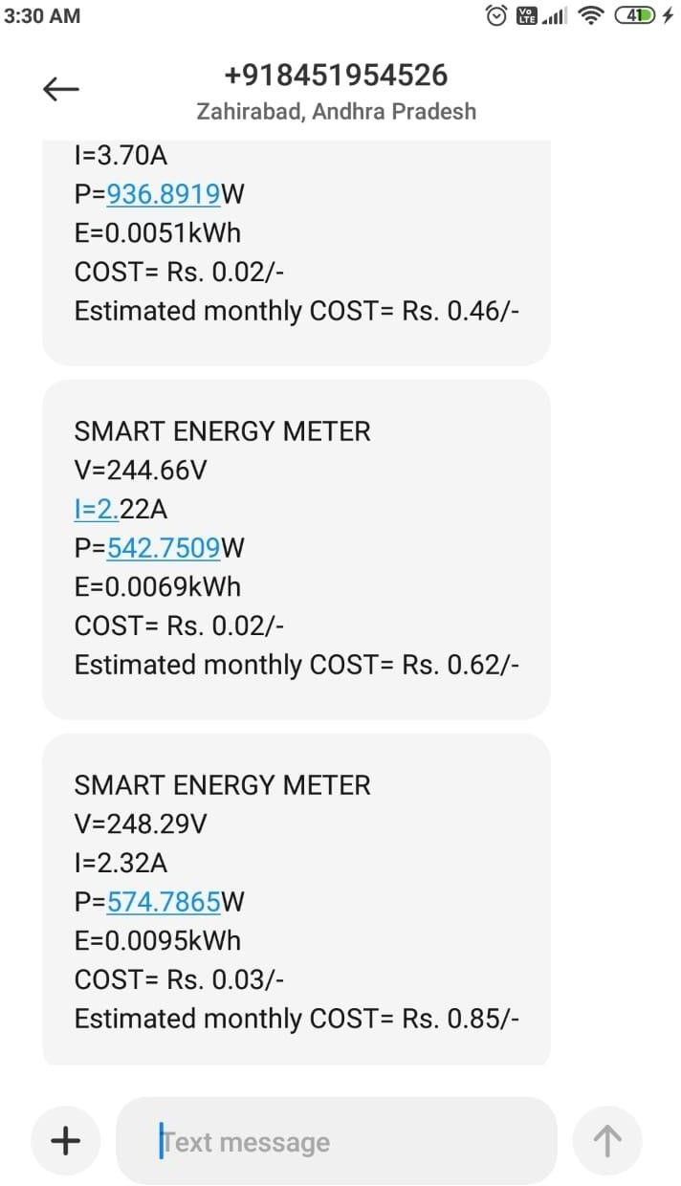

### Figure 16 - Screenshot of the Message Received

Our main goal was to send consumption data to customer via SMS. This was achieved using GSM. A SIM card was inserted in the GSM for this. The customer’s mobile receives a SMS from the number of the SIM card used in the GSM. He results can be seen below.

## Discussion

Comparison between existing meter and Smart meter :-

### Table 5 - Comparison between existing meter and Smart meter

|  |  |  |
| --- | --- | --- |
|  | Existing Meter | Smart Meter |
| Functions | Measure and Display Energy | Measure & Display Voltage,  Current, Power Energy |
| Cost | 700 Rs | 1000 Rs (2300Rs) |
| Justification |  | Send Daily usage to customer |

**Chapter 7** **Conclusion and Future Scope**

Smart energy metres have received a lot of attention recently, and the incorporation of innovative technologies like Arduino UNO, SCT013, ZMPT101B, and GSM SIM800L has boosted their performance even more. These components operate together to measure a household's energy consumption on a regular basis, providing significant insights into energy usage patterns.

The SCT013 and ZMPT101B sensors detect the current and voltage of the electricity consumption, respectively. This data is processed by the Arduino UNO, which determines the energy consumption in kWh. The GSM SIM800L module provides this information through SMS to the user's registered mobile number.

The key advantage of this system is that it gives real-time energy consumption statistics, allowing customers to monitor their usage and make adjustments to lower their energy consumption. Furthermore, the system can assess the cost of energy spent, providing consumers with an estimate of their monthly payment.

In conclusion, the usage of smart energy metres such as the Arduino UNO, SCT013, ZMPT101B, and GSM SIM800L is an innovative approach that can help cut energy use and expenditures. By providing consumers with real-time data, they can make informed decisions and take steps to reduce their energy usage, making it a powerful tool for promoting energy efficiency and conservation.

## 7.1 Future scope for smart meter

Smart grid: Smart grid is an integrated system of smart meters and devices which are connected over the internet for multi directional data transfer. Remote surveillance of meter can be done if smart grid is implemented.

Bill prediction using storage of values using Cloud storage: Values of daily consumption will be stored in a database and average consumption over a week can be calculated. This will help in accurate prediction of monetary bill.

Operating Devices using smart meter which has wifi module: Instead of Arduino Uno and GSM based meter, a WiFi module can be used for meter which can be connected to other devices such as Android TV, Smart Phones, Mobile operated home lighting. Security cameras etc. This will help in turning on/off these devices remotely.

Pre-paid meters: Pre paid meters are a reality in near future. It is similar to prepaid mobile service as the customer will pay first and then use electricity eliminating the possibility of billing disputes.

**References**

|  |  |
| --- | --- |
| [1] | "WHEN WAS THE WATT-HOUR METER INVENTED?," [Online]. Available: https://high-techs- base.com/article/when-was-the-watt-hour-meter-invented#. |
| [2] | "aivgu.makepcworks," [Online]. Available: https://aivgu.makepcworks.com/post/electric-fan-who- invented/21072076. |
| [3] | J. Kmety, "electrolibrary.info," [Online]. Available: [http://www.electrolibrary.info/history/historyelectroschet2.htm.](http://www.electrolibrary.info/history/historyelectroschet2.htm) |
| [4] | T. Bláthy, "patents.google," [Online]. Available: https://patents.google.com/patent/US423210A/en. |
| [5] | "fnofum.workwithmitchelle," [Online]. Available: https://sfnofum.workwithmitchelle.com/post/electrical-power-meter-motor/21029955. |
| [6] | A. A. Foroud, "slideshare.net," 11 06 2020. [Online]. Available: https://[www.slideshare.net/Alialshemary2/presentation-of-smart-meter.](http://www.slideshare.net/Alialshemary2/presentation-of-smart-meter) |
| [7] | "eurka.krsattys-riv," [Online]. Available: https://eurka.krsattys-riv.com/post/networked-circuit- induction-meter/79981054. |
| [8] | "sbvhz.kanakin," [Online]. Available: https://sbvhz.kanakin.com/post/multi-tariff-electricity- meter/103754520. |
| [9] | [Online]. Available: https://skmmart.com/product/non-invasive-ac-current-sensor-split-core- current-transformer-sct-013-000-100a/. |
| [10] | "bromleysat," [Online]. Available: https://bromleysat.com/product/sct-013-100a. |
| [11] | "packetpower," [Online]. Available: https://[www.packetpower.com/blog/split-core-solid-core-and-](http://www.packetpower.com/blog/split-core-solid-core-and-) why-you-should- care#:~:text=They%20operate%20by%20magnetically%20inducing,directly%2C%20would%20ov erpower%20the%20meters.. |
| [12] | "robocraze," [Online]. Available: https://robocraze.com/blogs/post/how-to-connect-zmpt101b-to- arduino#:~:text=The%20ZMPT101B%20is%20an%20AC,to%20generate%20an%20analog%20ou tput.. |
| [13] | "innovatorsguru," [Online]. Available: https://innovatorsguru.com/zmpt101b. |
| [14] | "nightshade.net," [Online]. Available: https://nightshade.net/product/arduino-uno-r3. |

|  |  |
| --- | --- |
| [15] | "esonlineservice," [Online]. Available: https://esonlineservice.com/product/arduino-uno-rev3- development-board/. |
| [16] | "docs.arduino.cc," [Online]. Available: https://docs.arduino.cc/hardware/uno-rev3. |
| [17] | "docs.arduino.cc," [Online]. Available: https://docs.arduino.cc/hardware/uno-rev3. |
| [18] | "components101," [Online]. Available: https://components101.com/wireless/sim800l-gsm-module- pinout-datasheet-equivalent-circuit-specs. |
| [19] | "analog," [Online]. Available: https://[www.analog.com/en/design-center/glossary/printed-](http://www.analog.com/en/design-center/glossary/printed-) circuit.html#:~:text=A%20printed%20circuit%20board%2C%20or,a%20working%20circuit%20or  %20assembly.. |

**Acknowledgement**

Our project has been a journey of learning and growth, and we are deeply grateful to the many individuals who have supported us along the way. Their guidance and counsel have been invaluable to the development and conclusion of our project, and we are truly fortunate to have received such support.

We would like to express our heartfelt appreciation to our project guide, Dr. Gajanan Thokal, whose keen interest in our work and unwavering support helped us to develop a high-quality system. His mentorship and provision of necessary information were crucial to our success. Despite his busy schedule managing the college affairs, he was always there to offer his expertise and support, and we are grateful for that.

We also extend our sincere thanks to Dr. Dhanraj Tambuskar, the Head of the Department of Mechanical Engineering, for providing us with the opportunity to undertake this project and for his unwavering support and guidance throughout the project duration.

We cannot forget to acknowledge the Principal of Pillai College of Engineering, Dr. Sandeep Joshi, whose encouragement and timely support were instrumental in our success. We are thankful for his continued guidance and leadership.

We would also like to express our appreciation to the Mechanical Engineering and Electronic Engineering Teaching Staff for their ongoing support, encouragement, and direction, which enabled us to complete our project successfully. Their expertise and dedication to our growth were invaluable.

Finally, we would like to thank the entire laboratory personnel for their prompt assistance and support throughout the project. We are truly grateful for their hard work and dedication to our success.

Rithesh P Karkera Abhishek S Athalekar Shubham R Mane Ikjot Singh Chhachhan